Country Code Change for firmware 1.025

Contact AIRAYA support FIRST to setup a time to have the key generating program running. (Phone: 408-776-2846, ext. 207, or email terry@airaya.com, or Skype airaya_support). All AIRAYA times are Pacific Time Zone.

Open two Command Prompt windows. One is to Telnet to your bridge (Window #1) and the other is to Telnet to our key generation program (Window #2). Disregard the quotes around any of the examples.

In Window #1 telnet to the IP address of your bridge. You will then sign on with your bridges ID and Password. After signing on to the bridge, type “admin” and hit enter. You will then get a challenge (example: cf6034247a7e6672). You will get a different challenge code each time you telnet into a bridge.

In Window #2, type “telnet 216.139.30.71 4999” and hit enter. You will see “Enter Challenge Value. Enter the value given in Window #1 (cf6034247a7e6672) and hit enter.

A value will be returned which is your key. This key needs to be entered into Window #1 (you only need to enter the first four characters of the key...ex. ba8a ). Hit enter then type “countrycode” and hit enter again.

Note: If you are changing the Country Code on more than one bridge, you must wait two minutes before trying to get another key from the key generating program.

The following screen shows this example:

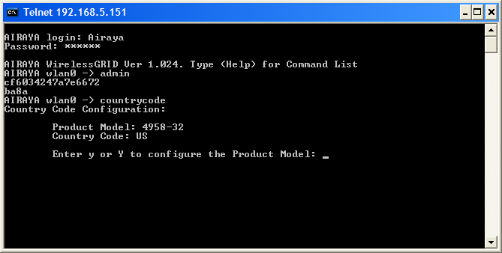

Enter an “n” at the prompt to bypass changing the Product Model and hit Enter. This does not need to be changed.

Type a “y” to bring up the list of Country Codes. Make sure you choose the one that fits the legal requirements of your area. In this example, I have chosen “7” for All Bands and hit enter.

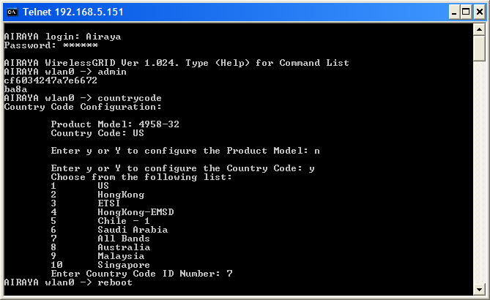

Type “reboot” at the next prompt and the bridge will reboot.

When your bridge comes back up, the Country Code will now be changed.

