Country Code Change for firmware 1.025

Contact AIRAYA support FIRST to setup a time to have the key generating program running. (Phone: 408-776-2846, ext. 207, or email terry@airaya.com, or Skype airaya_support). All AIRAYA times are Pacific Time Zone.

Open two Command Prompt windows. One is to Telnet to your bridge (Window #1) and the other is to Telnet to our key generation program (Window #2). Disregard the quotes around any of the examples.

In Window #1 telnet to the IP address of your bridge. You will then sign on with your bridges ID and Password. After signing on to the bridge, type “admin” and hit enter. You will then get a challenge (example: cf6034247a7e6672). You will get a different challenge code each time you telnet into a bridge.

In Window #2, type “telnet 216.139.30.71 4999” and hit enter. You will see “Enter Challenge Value. Enter the value given in Window #1 (cf6034247a7e6672) and hit enter.

A value will be returned which is your key. This key needs to be entered into Window #1 (you only need to enter the first four characters of the key...ex. ba8a ). Hit enter then type “countrycode” and hit enter again.

Note: If you are changing the Country Code on more than one bridge, you must wait two minutes before trying to get another key from the key generating program.

The following screen shows this example:

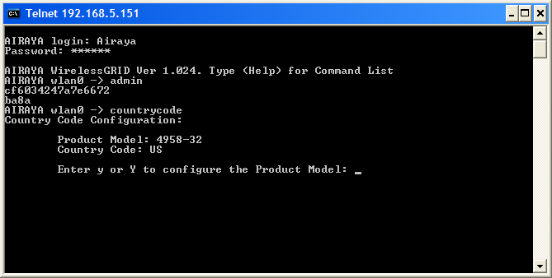

Enter an “n” at the prompt to bypass changing the Product Model and hit Enter. This does not need to be changed.

Type a “y” to bring up the list of Country Codes. Make sure you choose the one that fits the legal requirements of your area. In this example, I have chosen “7” for All Bands and hit enter.

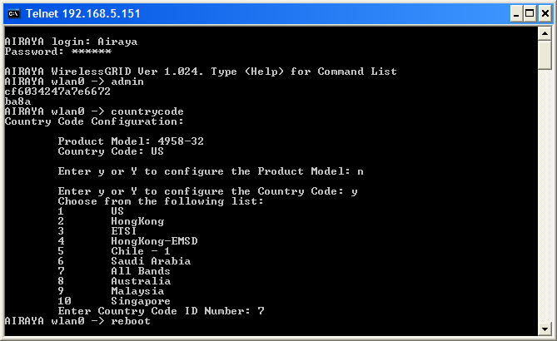

Type “reboot” at the next prompt and the bridge will reboot.

When your bridge comes back up, the Country Code will now be changed.

4dc55212df9f2eea 5603975552347090666
32e798bd250d202a 3668068359654416426

0dfd5f31456105d8 1008066556822881752
a737d7fb978c609e 12049336803632373918

3d71d182c13f9c94 4427550268200033428
444906d857d04db9 4920471594134949305

0491fbeeb0a689da
3e1864efd2ca48a9

5eceff22c997e441
14f59306da3ecf82

