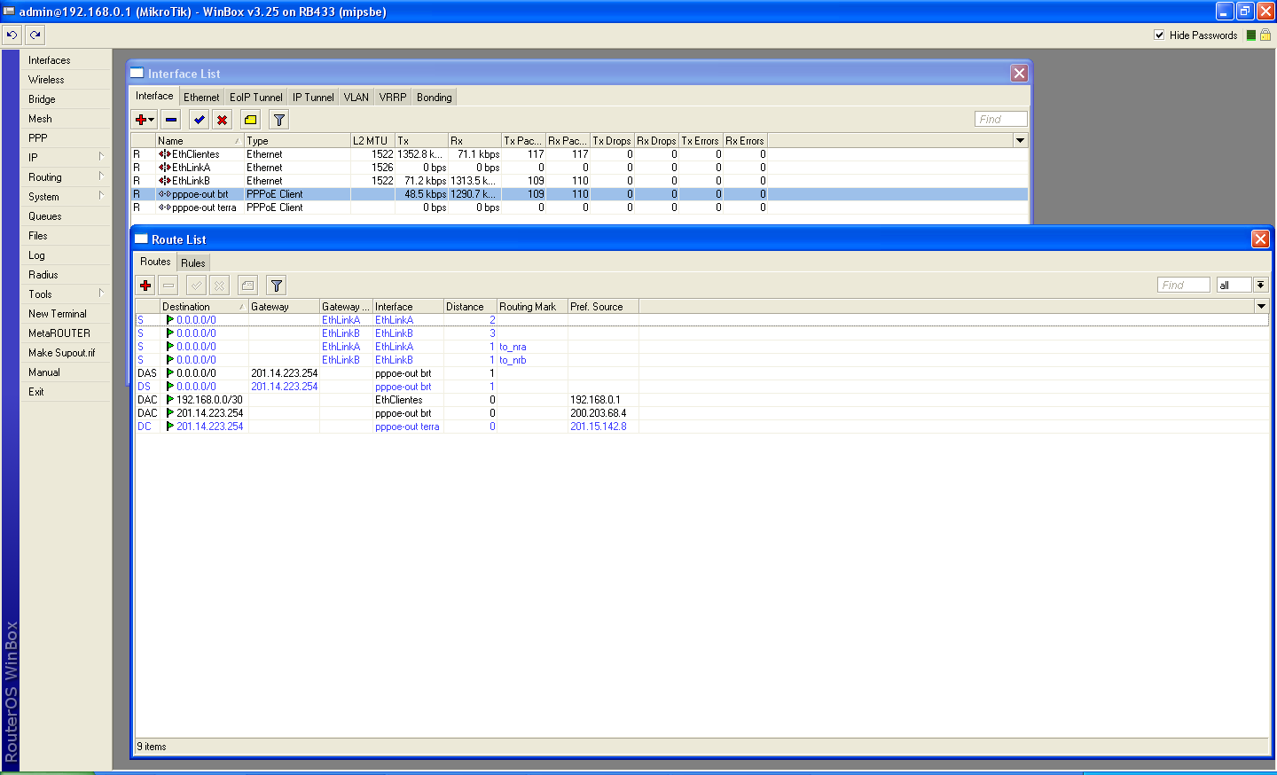

mangle
0 ;;; SEM BALANCE
chain=prerouting action=accept dst-address-list=sem_balance in-interface=EthClientes

1 chain=input action=mark-connection new-connection-mark=conn_na passthrough=yes connection-state=new in-interface=EthLinkA

2 chain=input action=mark-connection new-connection-mark=conn_nb passthrough=yes connection-state=new in-interface=EthLinkB

3 chain=output action=mark-routing new-routing-mark=to_ra passthrough=no connection-mark=conn_na

4 chain=output action=mark-routing new-routing-mark=to_rb passthrough=no connection-mark=conn_nb

5 chain=prerouting action=mark-connection new-connection-mark=conn_ma0 passthrough=yes dst-address-type=!local in-interface=EthClientes
per-connection-classifier=both-addresses:2/0

6 chain=prerouting action=mark-connection new-connection-mark=conn_mb1 passthrough=yes dst-address-type=!local in-interface=EthClientes
per-connection-classifier=both-addresses:2/1

7 chain=prerouting action=mark-routing new-routing-mark=to_nra passthrough=no in-interface=EthClientes connection-mark=conn_ma0

- chain=prerouting action=mark-routing new-routing-mark=to_nrb passthrough=no in-interface=EthClientes connection-mark=conn_mb1

[admin@MikroTik] /ip firewall nat> print
Flags: X - disabled, I - invalid, D - dynamic
0 ;;; MASCARAMENTO PCC
chain=srcnat action=masquerade src-address=192.168.0.0/24

[admin@MikroTik] /ip route> print
Flags: X - disabled, A - active, D - dynamic, C - connect, S - static, r - rip, b - bgp, o - ospf, m - mme, B - blackhole, U - unreachable, P - prohibit
# DST-ADDRESS PREF-SRC GATEWAY-STATE GATEWAY DISTANCE INTERFACE
0 S 0.0.0.0/0 unreachable EthLinkA 2 EthLinkA
1 S 0.0.0.0/0 unreachable EthLinkA 1 EthLinkA
2 S 0.0.0.0/0 unreachable EthLinkB 3 EthLinkB
3 S 0.0.0.0/0 unreachable EthLinkB 1 EthLinkB
4 ADS 0.0.0.0/0 reachable 201.14.223.254 1 pppoe-out brt
5 DS 0.0.0.0/0 reachable 201.14.223.254 1 pppoe-out brt
6 ADC 192.168.0.0/30 192.168.0.1 0 EthClientes
7 ADC 201.14.223.254/32 200.203.68.4 0 pppoe-out brt
8 DC 201.14.223.254/32 201.89.166.34 0 pppoe-out terra

