NanoStation 2 por dentro.
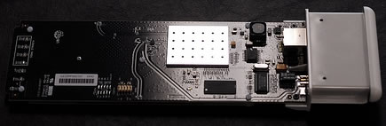
vista superior

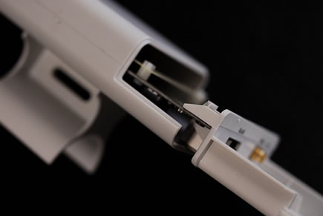
Nanostation2

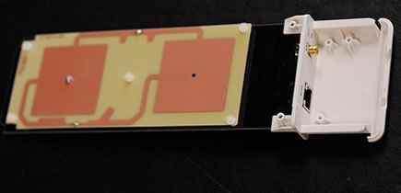
Vista superior pcb antena

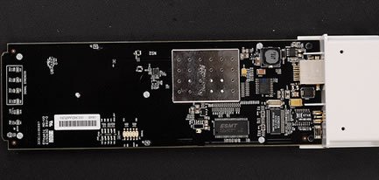
vista superior pcb radio

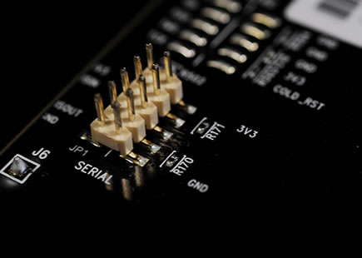
Vista superior ponto J tag serial

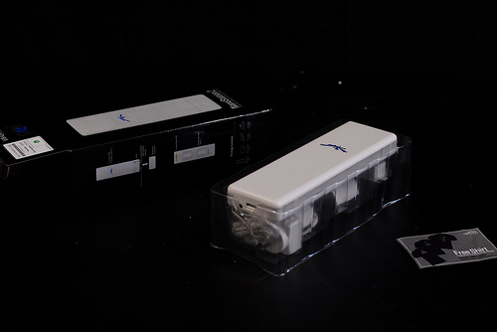
The Ubiquiti Nanostation 2 (NS2) has been a fast mover since it was introduced. We order a bunch, they all go out the door, we order more. Rinse, repeat. For us as a store, it’s a great product. We don’t have to do any custom work on them, and though the margins are thin, they don’t sit in our inventory long. For you, the customer, it’s a powerful piece of hardware at a rock bottom price.
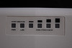
By the specs alone, it’s a very impressive device. The Nano Station 2 is a small, waterproof CPE with a 400mw 802.11b/g radio and a dual polarity 10dbi antenna. It does POE (with included adapter), mounts to a pole, and has an external SMA (regular, not reverse polarity) connector. Added bonus, LEDs for RSSI while you set it up. It runs AirOS, which is Ubiquiti’s linux variant, and it’s only a matter of time before they’re running OpenWRT (check the support page for updates on firmware). As far as price goes, nothing out there beats it. It even comes with an offer for a free shirt!
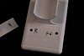
Today I decided it was time to open one up and see what it was made of. The nanostation is very smooth, and it took me a minute or two to figure out how to get it open. Of course, rule #1 of taking apart stuff is to find out what the stickers are hiding. Underneath this little guy’s mac address are two small screws. Unscrew, and the board just slides right out. You really can’t get any easier than that. I was pretty happy I didn’t have to squeeze, twist or bust a fingernail trying to crack open the case.
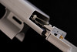
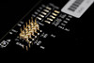
The board is a bit longer (a little over 8 inches) than I had imagined, especially after seeing the pictures of the upcoming picostation, but it makes sense that it’d be the length of the device (just over 10 inches). The antenna is actually mounted right to the back (front?).
One nice surprise for the hardware hackers is the serial port, which is already pinned out. No need for solder! If you want to JTAG, the pads are exposed and ready, but I imagine the serial will fit most people’s needs.
Here’s the front (back?) of the board.
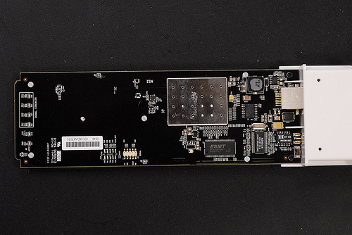
Here’s the back (front?) with the antenna.
